Sunday | Monday | Tuesday | Wednesday | Thursday | Friday | Saturday
 |  |  |  |  |  | 1
2 | 3 | 4  Mardi Gras | 5 | 6 | 7 | 8
9  Daylight Saving Time Begins | 10 | 11 | 12 | 13  Purim Begins | 14 | 15
16 | 17  St. Patrick’s Day | 18 | 19 | 20  Spring Begins | 21 | 22
23 | 24 | 25 | 26 | 27 | 28 | 29
30 | 31

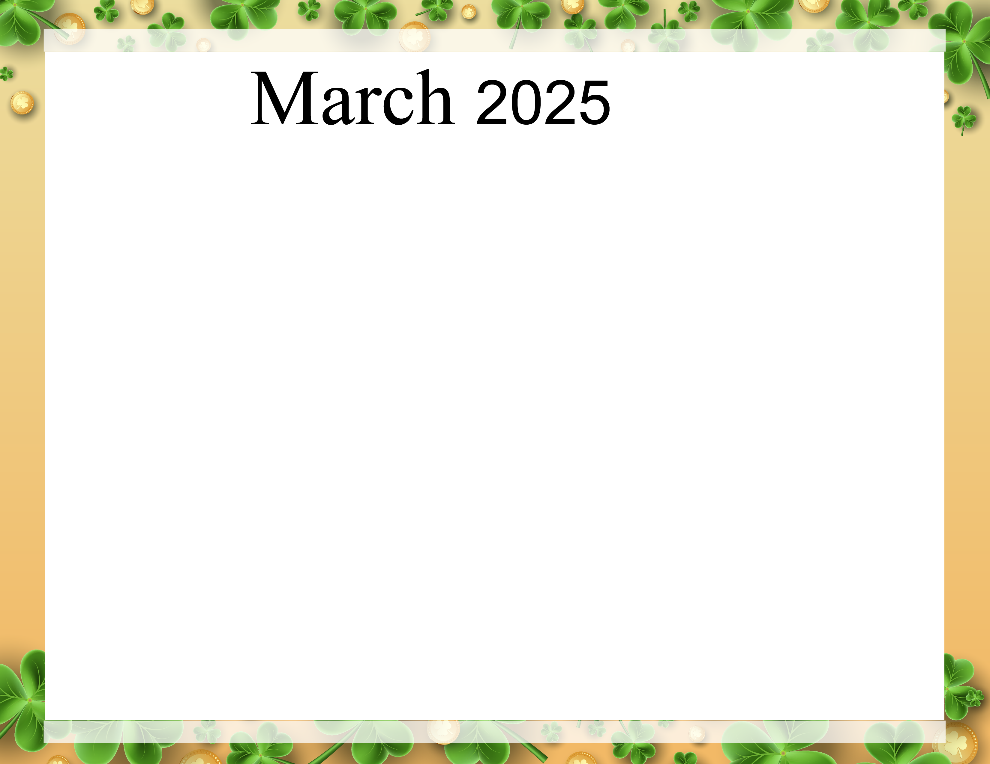  Evergreen Post Acute |  |  |  |  |  | 10:00-Sisters of Charity-Seaside  2:00-Bingo-Sierra
10:00-Song and Scripture  2:30-Faith Baptist  Dr. Seuss’s Birthday | Dr. Suess Day  10:00-Drawing Club  10:00-Dr Suess Hat Craft  2:00-Bingo  2:00-Bingo  Wear Red or Blue Day | 10:00-Mardi Gras Mask on a Stick  10:00-Travel to New Orleans  2:00- Bracelets  2:00-Fat Tuesday Fill In | 10:00-Coffee Social  10:00-Moving to the Oldies  1:00-Ash Wednesday  2:00-Bingo  2:00-Bingo | 10:00-Adult Coloring  10:00-Guess the Movie by the Song  2:00-Ticklish Humor Game  2:00-Math Challenge | 10:00-Deal or No Deal  10:00-Travel to Chicago  2:00-Movie  2:00-Bingo-Seaside | 10:00-Word Games  2:00-Bingo-Sierra
10:00-Song and Scripture  2:00-Smyrna Wesleyan Church  Daylight Saving Time | 10:00-Hidden Puzzles  10:00-Pretty Nails  2:00-Bingo  2:00-Bingo | 10:00-Shamrock Painting  10:00-Bean Bag Toss  2:00-Learing Sign Language  2:00-Spring Recipes | 10:00-Coffee Social  10:00-March Trivia  2:00-Bingo  2:00-Bingo | 10:00-Bowling  10:00-Adult Coloring  2:00-Music with Howard Isenberg  2:00-Dominos | 10:00-Travel to Ireland  10:00-St. Patrick’s Day Photos.  2:00-Bingo  2:00-Bingo-Seaside | 10:00-You Be the Judge  2:00-Imagine-Sierra
10:00-Song and Scripture  2:00-Faith Baptist | 10:00- Bingo  10:00-Bingo  2:00-St Patrick’s Day Activities | 10:00-Movie Character Guess Who  10:00-Parachute Fun  2:00-Resident Council  2:00-Carol Regan | 10:00-Coffee Social  10:00-Spring Collage  2:00-Bingo  2:00- Bingo | 10:00-Jeopardy  10:00-Whats in the Bag  2:00-Food Committee Meeting  2:00-Spring Flower Craft  5:00-Eden International | 10:00-Chess and Checkers  10:00-Bingo-Seaside  2;00-Movie  2:00-Music with Clem Bowden-Seaside | 10:00-Sisters of Charity-Sierra  2:00-Bingo-Sierra
10:00-Song and Scripture  1:30-Centennial Church | 10:00-Target Practice  10:00-Pretty Nails  2:00-Bingo  2:00-Bingo | 10:00-Pictionary  10:00-Can you Spell it  2:00-Learning Sign Language  2:00-Cooking Show | 10:00-Bingo  10:00-Bingo  2:00-Music with Susette Prichett | 10:00-Piviot Point Game  10:00-Do you Hear What I Here  2:00-Clothing Giveaway | 10:00-Cherry Blossom Painting  10:00-Travel to Washing DC Cherry Blossom Tour  2:00-Card Games  2:00-Uno | 10:00-Name that Tune  2:00-Bingo-Sierra
10:00-Song and Scripture  2:00-Faith Baptist | 10:00-Pretty Nails  10:00-Reminicing Square Dancing  2:00-Bingo  2:00-Bingo
Subject to Change

